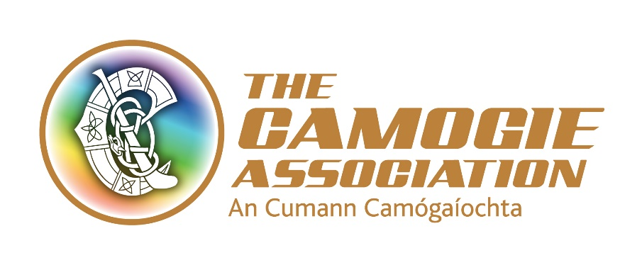

Síghle Nic an Ultaigh Administrators Award 2019

Nomination from (Comhairle)

Please submit your unit’s nomination for consideration to Sarah Stanley, Office Administrator by Monday 15th February, giving details of the contribution to an Cumann Camógaíochta made by your nominee.

Nominees must have served the Association for a minimum of ten years at County, Provincial or National level to be eligible for consideration.

Name of Nominee:

Address:

Positions held: (please state at what level these positions were held and for how long)

Overall contribution to the development of Camogie:

Signed by:

Date:

This form must be returned by Friday 15th February to: Sarah Stanley, Office and Communications Administrator, an Cumann Camógaíochta, Croke Park, Dublin 3.

PLEASE NOTE: LATE APPLICATIONS WILL NOT BE CONSIDERED

