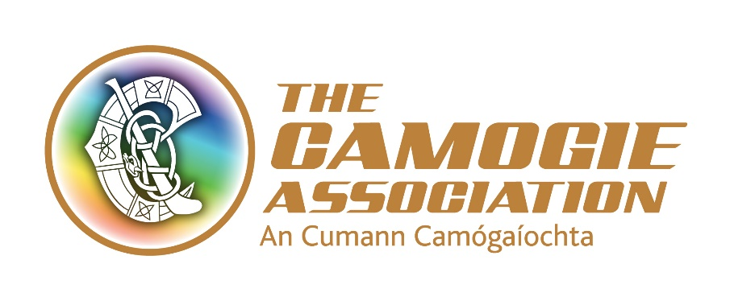

Síghle Nic an Ultaigh Administrator’s Award 2020

Nomination from (Comhairle)

Please submit your unit’s nomination for consideration to Sarah Stanley, Office Administrator by Friday 14th February, giving details of the contribution to an Cumann Camógaíochta made by your nominee.

Nominees must have served the Association for a minimum of ten years at County, Provincial or National level to be eligible for consideration.

Name of Nominee:

Address:

Positions held: (please state at what level these positions were held and for how long)

Overall contribution to the development of Camogie:

Signed by:

Date:

This form must be returned by Friday 14th February to: Sarah Stanley, Office and Communications Administrator, an Cumann Camógaíochta, Croke Park, Dublin 3.

PLEASE NOTE: LATE APPLICATIONS WILL NOT BE CONSIDERED

